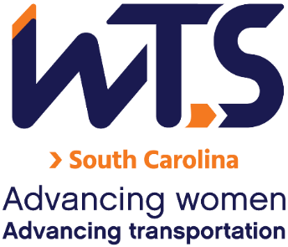

2025 WTS Sharon D. Banks Memorial

Undergraduate Scholarship

WTS fosters the development of women in the transportation field by encouraging bright new professionals to undertake careers in the area of transportation. One way it does this is by awarding the WTS Sharon D. Banks Memorial Scholarship to women pursuing undergraduate studies in transportation or a related field.

The scholarship honors Sharon D. Banks, chief executive officer of AC Transit in Alameda-Contra Costa County, California. As its CEO throughout most of the 1990’s, Banks led the agency in a pioneering effort to introduce cultural and organizational changes aimed at motivating the public transit workforce. She was a member of the WTS Advisory Board and received the WTS San Francisco Chapter Woman of the Year and Employer of the Year awards.

The minimum criteria for selection are:

- GPA of 3.0 or higher
- Currently enrolled in an undergraduate degree program in a transportation-related field, such as transportation engineering, planning, finance, or logistics
- Plans to pursue a career in a transportation-related field

To be considered for our SC scholarships, applications should be submitted to the WTS South Carolina Chapter as typed documents. Scholarships are competitive and based on the applicant's specific transportation goals, academic record, and transportation-related activities or job skills. Applications are due April 25, 2025.

The WTS South Carolina Chapter awards banquet is tentatively scheduled for August 2025. Local winners will be forwarded and considered for the 2025 WTS Foundation (National) Awards. National awards will be presented during the Annual Conference and attendance during the awards ceremony is strongly recommended. Conference registration for scholarship winners is complimentary. Local chapters will assist with arrangements upon selection.

2025 WTS Sharon D. Banks Memorial Undergraduate Scholarship

Application

  - Personal Information

Name Last First Middle
E-mail Address Primary Phone Current Address (Street, City, State, Zip):

Permanent Address (Street, City, State, Zip):

Educational Background
Current College/University City, State Expected Date of Graduation
Degree to be Received
Area of Concentration Grade Point Average
(Minimum GPA of 3.0 required. Attach an official copy of the transcript to the application.) Previous Colleges/Universities Attended, Date Degree Earned and GPA:

Professional or School Affiliations (List any school, professional or community activities you have participated in. Include offices held and awards received. Attach additional sheets, if necessary, as typed word documents.)

Employment History

Work Experience (List full-time, part-time, co-op, and summer employment. Briefly describe duties and responsibilities. Attach additional sheets, if necessary, as typed word documents.)

  - Recommendation: A letter of recommendation by a professor or job supervisor must accompany your application.

  - Personal Statement: A statement about your career goals and/or continuing education after graduation and why you think that you should receive the scholarship award. Applicants must address the issue of leadership, its importance in a transportation career, and the applicant’s leadership achievements. The statement should not exceed 500 words. Please attach to the application form as a typed word document.

  - Proof of Enrollment: Attach a copy of your tuition receipt or current registration card.

Applicant Signature Date

Please send the application and attachments as A SINGLE PDF with the subject line “Scholarship” to: SouthCarolinaWTS@gmail.com

