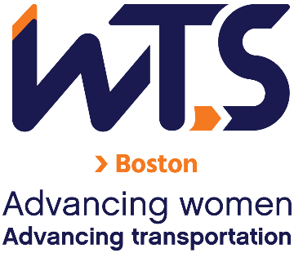
WTS-Boston Chapter Mentoring Program
Mentor Application

The WTS-Boston Mentoring Committee is seeking participants for the 2025 Mentoring Program. Please take a few minutes to review the program details below and consider becoming a mentor in the WTS-Boston Mentoring Program. Mentors will be paired with mentees based on their career/employment background, leadership experience, and the mentee’s stated professional and mentoring program goals. Previous mentoring experience is not necessary but is a plus.
Applications are due November 29, 2024 to wtsbostonmentoring@gmail.com.
Eligibility Criteria and Requirements
Eligibility:
- Current Member of WTS-Boston. To join WTS, visit the following link: https://www.wtsinternational.org/home/membership
- Members who hold senior positions in transportation, public policy, or related fields and have the desire to assist others to grow personally and professionally; and/or
- Industry professionals with extensive experience in their chosen field with the ability to inspire their Mentees to learn and grow, seek new possibilities, take calculated risks and act as allies, catalysts and coaches;
- Ability to make a 6-month commitment from January-July 2025 encompassing about 4 hours/month to the program. Group sessions will be conducted via Google Meet during a Wednesday lunch hour once per month. Mentor and mentee pairs should meet 1-on-1 once per month as well.

Requirements:
- Complete this application.
- Submit a resume and headshot (JPEG or PNG format please).
- Submit a 50 - 100 word bio describing your work history, leadership, and mentoring experience.
Note: Preference will be given for those who can attend two in-person meeting sessions.

Application
Name
Employer and/or Organization
Position
Email
Phone Number

- What are your expectations of the Mentoring Program? Why would you like to participate in the Program?

- Please note your preferred days/times to meet and preferred way to communicate with your mentee.

- Please mark your top five preferences for professional development topics in the following table.
Topics | Mark 1 - 5 in this column next to your preferred topics.
- Mini-interview workshop (Elevator pitch practice/tips)
- Asking for a promotion or raise
- Effective networking
- Managing up
- How to deal with shifting sand at work/AI/automation
- Public speaking
- How to handle disagreements in a professional team
- How did you get where you are
- Effective communication at work
- Skill-building for your next role/
Preparing for your next promotion
- Leadership
- Considering parenthood/work-home balance
- Gender dynamics in the workplace
- Measuring success/importance of failure
- Strategies for working in a hybrid environment

Applications are due by November 29, 2024 to wtsbostonmentoring@gmail.com.

